Written evidence submitted by Turn2us for Women and Equalities Select Committee Inquiry: Coronavirus and the impact on people with protected characteristics
About Turn2us
Turn2us is a national charity that provides practical information and support to millions of people across the country, who are facing financial shocks. We work alongside those who have experienced not having enough money to live on to develop practical information and support that helps people cope with life-changing events such as job loss, illness or bereavement. This includes information on the benefits they are entitled to; and the support they can access through charitable grants.

Each year, we give approximately £3m to households struggling to make ends meet and help over three million people towards greater financial stability through our website and helpline. Over seven million people visit the Turn2us website over the course of the year; and our helpline which provides guidance to individuals on their benefit entitlement handles roughly 80,000 enquiries. Historically 75% of people searching for grants have been women. Many of the people we support have been affected by a life-changing event that has affected their income and put them at risk of financial crisis.

Since the coronavirus pandemic

The coronavirus outbreak has led to an unprecedented demand for our services. We have seen a 200% increase in people checking their entitlement to benefits, with over 800,000 households completing a benefits calculation. During the same period, over 140,000 households searched for a charitable grant for financial support: a 109% increase in demand for financial support.

Since the outbreak of the crisis 56% of the funds we have awarded in grants have been awarded to women compared to 44% to men.

Evidence
Turn2us commissioned two nationally representative surveys of working age adults to understand how the pandemic was affecting them. The first survey had a sample size of 2,014 and the second 2,500 (of which 2,000 were working age). Our analysis has revealed a number of differences in the impact of coronavirus based on demographic factors.
Economic impact of coronavirus on women
Our analysis revealed that women were expecting a greater fall in income than men, leading to an increase in the gender pay gap of £62 a month. On average, men’s incomes were expected to drop by £247 (18%), whilst women’s incomes were expected to fall by £309 (26%). Additionally, in two-parent households that are employed, the average reduction in pay that women anticipated is £405 per month, compared to £309 for men.
Regression analysis has suggested gender plays a significant part in determining the likelihood of economic impact from coronavirus. We speculate that this disproportionate impact could be partly driven by industries with larger female workforces being worst affected by the coronavirus outbreak, leading many employees to be furloughed or made redundant. This includes industries such as retail, hospitality, and leisure.
“I’m on a zero hours contract and have no idea what support I can get to pay bills and feed my 4 children. I now have no income. My husband can work from home but his wage reduced by 20% because the company he works for is struggling.” Kerry, Hospitality Worker
For working couples we also believe that unequal childcare and household responsibilities between the genders could also be a contributing factor to unequal impacts from coronavirus. On average, women carry out 60% more unpaid work than men.
Economic impact of coronavirus on single parents (the vast majority of whom are women)
The percentage of single parent families who anticipated that they would have £1,000 or less in April was 66%, up from 54% in February. That equates to 1.2 million single parents anticipating that they would be living on £1,000 or less in April, an increase of 216,000 compared to February, before coronavirus measures began. Additionally, 42% of single parents are anticipating living on less than £500 per month.
“I run a business supporting the elderly which I’ve had to stop to keep others safe. As a single parent there is no one else to pay the bills during this time.” Helen, Support Worker
Economic impact of coronavirus on different ethnic groups
According to our analysis, minority ethnic workers are more likely to have had their employment affected by coronavirus than White or White British respondents.
Ethnicity | Employment has changed due to coronavirus
Asian or Asian British | 60%
Black or Black British | 55%
Mixed | 49%
White or White British | 47%
Regression analysis suggests that the main cause of a loss of income is due to working in a zero hours contracts or being self-employed. We believe that the differential impacts seen by people from ethnic minority groups are primarily because they are over-represented in insecure forms of employment.
There were also large disparities in the number of respondents who said they planned to claim Universal Credit, as a result of coronavirus. Asian or Asian British respondents were almost twice as likely to be planning to claim Universal Credit as White or White British respondents (19% and 11% respectively. Black or Black British (17%) and Mixed (15%) respondents planning to make a Universal Credit claim were also significantly higher than White or White British.
We’ve also seen significant differences in how people with different ethnicities’ ability to pay their bills have been affected. Asian or Asian British respondents who have seen their employment affected report that they are at higher risk of being unable to afford their rent or mortgage payments than other ethnic groups.
Ethnicity | At risk of being unable to pay rent or mortgage bills
Asian or Asian British | 22%
Black or Black British | 13%
Mixed | 14%
White or White British | 16%
Impact of coronavirus on people with disabilities
Workers with a disability are more likely to have had their employment affected by coronavirus than workers without a disability. The employment of 65% of disabled workers has been affected compared to 46% of workers without a disability.
People with disabilities are also more likely to be planning to apply for Universal Credit, as a result of coronavirus – 18% compared to 10% for workers without a disability.
Regression analysis suggests that people with a disability are more likely to face a loss of income due to being overrepresented in less secure forms of employment, such as zero-hours contracts or self-employment.
Intersectional analysis
We have also undertaken some intersectional analysis looking at the impact of coronavirus based on multiple characteristics.
It’s clear that different demographic factors do not work in isolation and pre-existing inequalities are exacerbated by the crisis. Any response to the virus should recognise the differential impact on people with intersecting protected characteristics. , and address the structural inequalities that lead to certain demographic groups bearing a greater impact from the virus.
Respondents whose employment has been affected due to coronavirus, by gender and ethnicity:
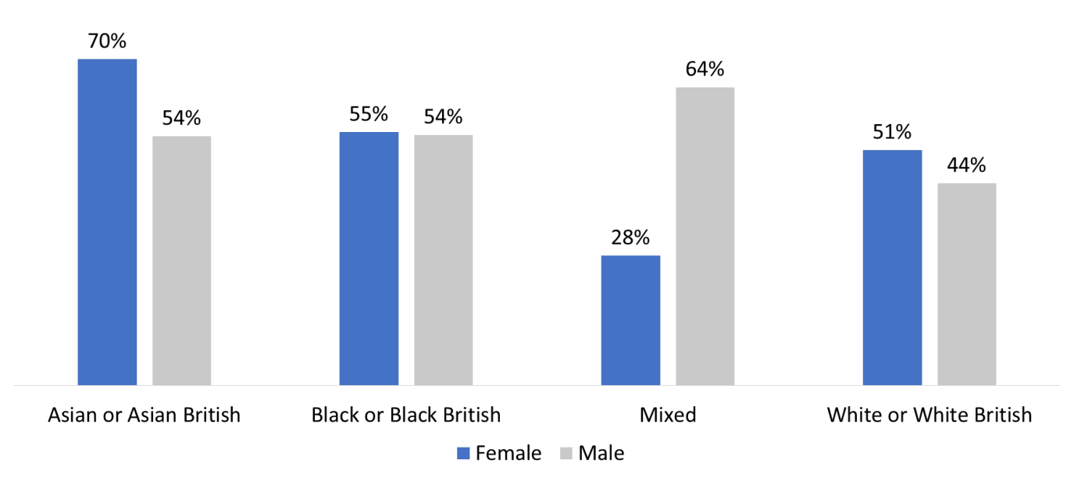
A significantly higher proportion of Asian or Asian British females (70%) reported their employment had been affected than any other group. Males in the Mixed group (64%) were also more likely to have reported an impact, whilst females in this group were significantly less likely (28%).
Respondents planning to claim Universal Credit due to coronavirus, by gender and ethnicity:
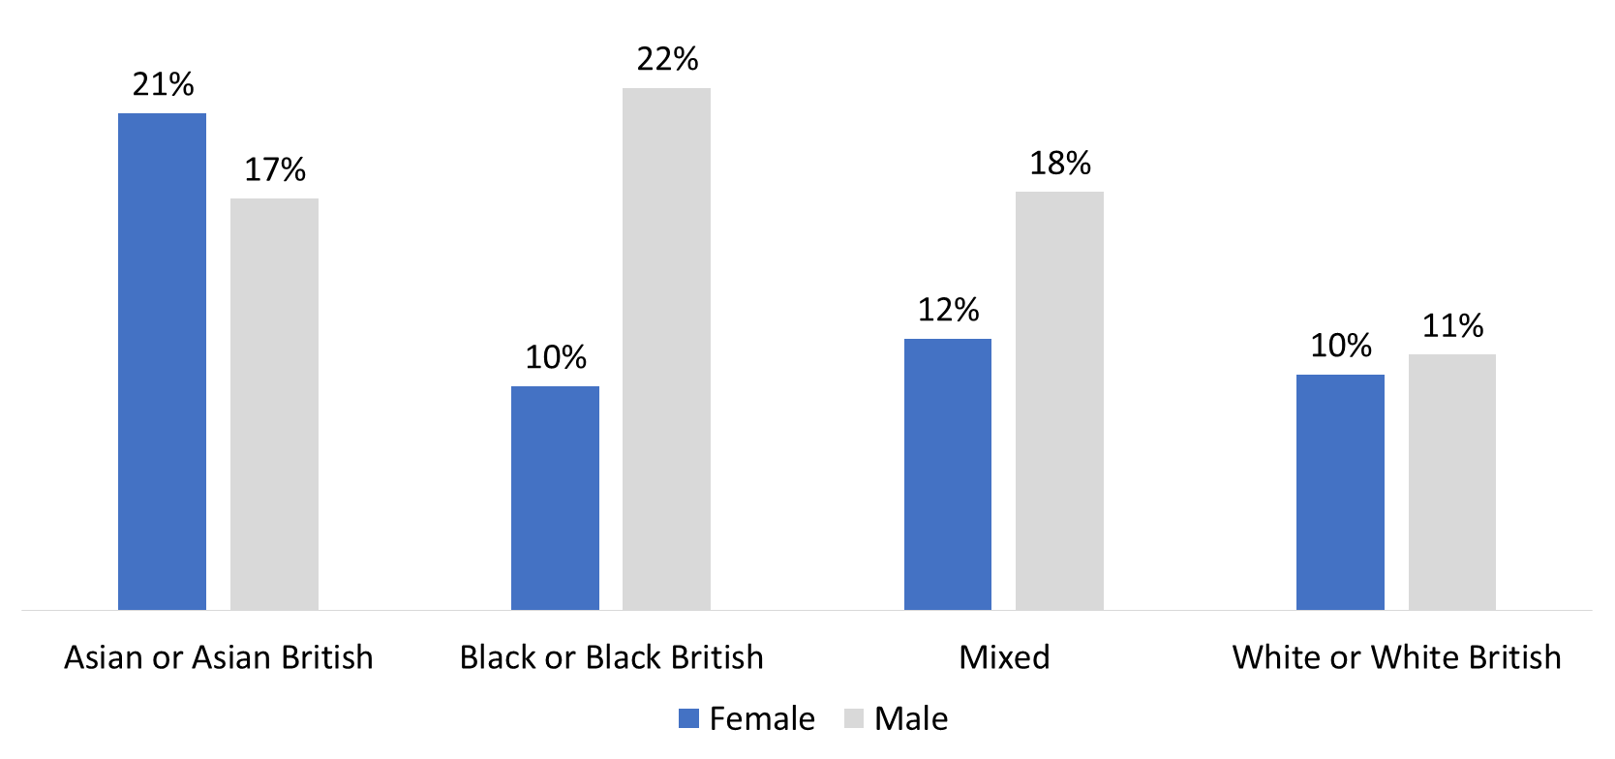
Interestingly, for most ethnic groups males were more likely to be planning to make a claim for Universal Credit than women. Most significantly Black or Black British men were twice as likely to be planning to make a claim as Black or Black British women, or White or White British men.
The proportion of Asian or Asian British people planning on making a claim was higher for both genders than the average for other ethnic groups. Asian or Asian British women were particularly likely to be planning to make a claim at 21%, compared to 17% for men.
Respondents whose employment has affected due to coronavirus, by gender and disability:
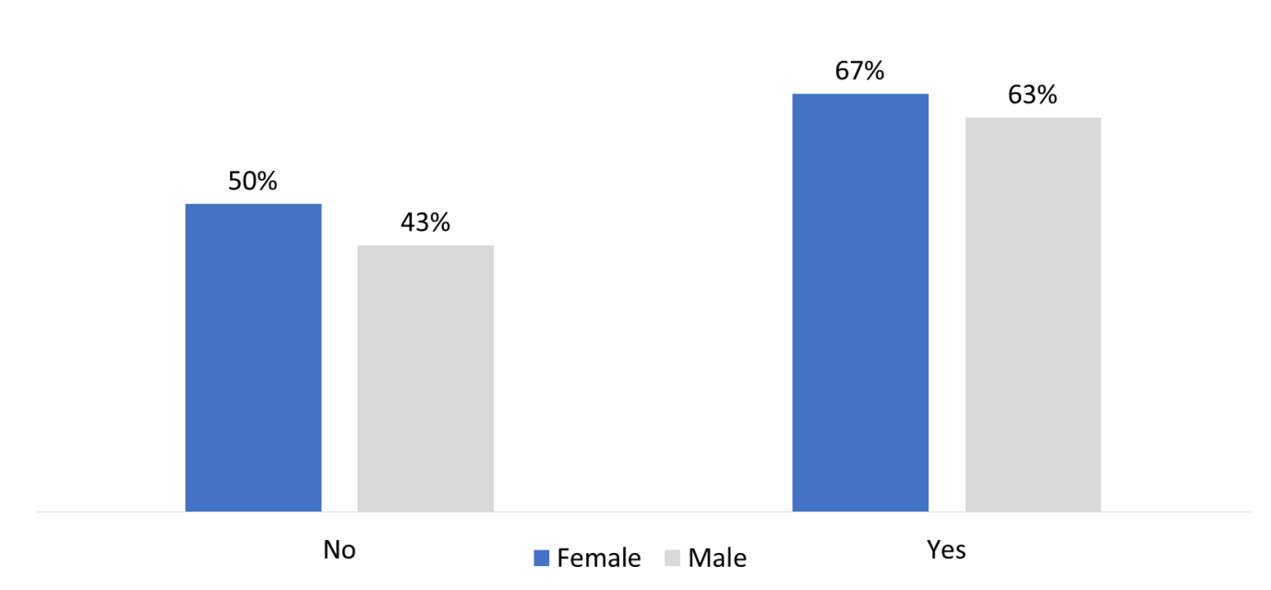
People with a disability were overall more likely to report that their employment had been affected. Similarly women were more likely to report this. Interestingly the difference between women and men reporting that their employment had been affected decrease if they were disabled.
Respondents planning to claim Universal Credit due to coronavirus, by gender and disability:
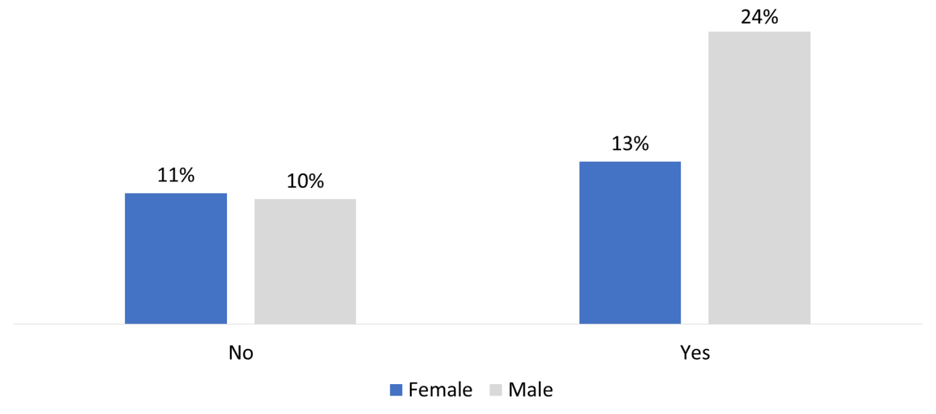
Men with a disability are significantly more likely to be planning to make a claim for Universal Credit than both women with a disability, and people without a disability.
Conclusions
Using regression analysis, we have determined that the most likely cause of a loss of income is due to working on zero hours contracts or being self-employed. Gender is also a significant predictor of greater financial impact. We believe that the differential impacts seen by people from ethnic minorities and by people who are disabled, are primarily because they are over-represented in insecure forms of employment.
Recommendations
More work needs to be done to understand both what impact coronavirus has on people with different protected characteristics and the specific reasons why certain groups are being worse affected. Many of the causes may be due long-term structural inequalities within our society and economy, such as the greater likelihood of being in poverty or being employed in a particular position or sector for particular demographic groups. Any response to this crisis should include an understanding and resolution of these causes.
Our recommendations largely relate to our field of expertise on financial hardship and all of these should be seen through the lens of understanding the differential impact on people with protected characteristics. There are currently differences in the financial aid across different forms of employment, which have a knock on effect on people with different protected characteristics. The government needs to ensure equity across all forms of employment.

We believe that our recommendations focusing on the financial impact on people will benefit people with protected characteristics the most:

- An income level that keeps people out of poverty
Recent changes such as the increase in the Universal Credit standard allowance rate are welcome in terms of giving an uplift to people’s incomes. A more developed support package should ensure that everyone will have enough money during this crisis period to afford the essentials, for example by:

- Ensuring increases in Universal Credit are reflected in increases to legacy benefits
- Lifting the benefit cap during this time to ensure that the support scheme benefits everyone
- Raising Statutory Sick Pay and extending coverage of this scheme to lower paid groups

- Reducing costs to help people stay afloat

As a key part of ensuring that the income people have makes a meaningful difference and finds its way straight in to people’s pockets, the Government must ease the pressure on people in terms of their outgoings – as it has done for some groups in society through measures such as mortgage holidays. A comprehensive support package would take account of people’s outgoings and how these can be minimised during this crisis period, for example by:

- Extending the suspension of benefit deductions to cover advance payments. This would ensure no current claimants lose out during this time due to previously taken advances, while new claimants can take out an advance payment to access money urgently while they wait for their first Universal Credit payment without fear of hardship down the line – and could be achieved through existing mechanisms
- Carrying out a rapid assessment of the extent to which the Hardship Fund for local authorities in England is enabling councils to provide crisis grants to vulnerable individuals and households, and provide additional funding and guidance to ensure all needs are being met, including for areas that don’t have a local welfare assistance scheme.
- Ensure that people are not having to continue to pay retainers for childcare, and support key workers with childcare where they may be incurring additional cost

- Making sure no-one in financial need misses out

We need to make sure that everyone experiencing or at risk of financial hardship benefits from these measures and gets additional support where needed. The support package must work for those who face additional costs (such as families with children) or who would be normally ineligible for welfare support, for example by:

- Suspending the two-child limit to ensure families can access the level of support they need to stay afloat
- Increasing benefits that go to families to help with the costs of raising children, for example through child benefit, the child element of Universal Credit, and child tax credit
- Suspending No Recourse to Public Funds conditions for people in serious financial hardship or risk of homelessness, during this time when people may be unable to access their usual forms of support

