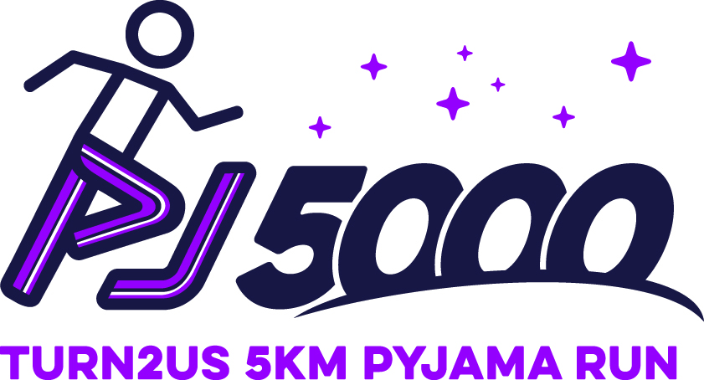

Name
Title
Company
Address
City
Postcode

Dear XXX
On behalf of Turn2us, we would like to invite XXX to sponsor our inaugural PJ 5000 events.
The Turn2us PJ 5000 is a 5000 metre (5km) race run in pyjamas. Targeted participants are students and young adults, 18-27 year olds who are active people looking for a fun challenge event and to support Turn2us’ fight against UK poverty.
You will have the opportunity to set up your own marquee or display at the beginning and end of each race (same position) to promote your products/services. This opportunity could be particularly beneficial for you …. (XXX talk in more detail about the company here e.g. Pyjama Company giving out vouchers)
We look forward to hearing from you in the hope of developing a future relationship between XXX and Turn2us. We would love to meet you at your earliest convenience to discuss this opportunity further and answer any questions you may have.

Yours sincerely,

Sponsorship Proposal
WHO ARE WE?
Our charity came into being at a social gathering in 1897 when our founder, Elizabeth Finn, , read out accounts from people who were living in poverty. Her audience were so moved that many wanted to help and volunteered to fundraise and ask their friends to support the cause.
Turn2us today is a national charity that helps people in financial hardship to gain access to welfare benefits, charitable grants and support services.
We do this through our website, helpline and workshops for staff and volunteers from partner organisations which provide face-to-face advice and help, so that they can support clients in financial need using our online tools. We also give direct financial support through a number of charitable funds, including the Elizabeth Finn Fund and the Edinburgh Trust.
We’ve had a long and varied history over the years, but our mission has always been the same; to fight poverty in the UK and Ireland and make life better for people in financial hardship.
THE TURN2US PJ 5000
The Turn2us PJ 5000 is a 5000m (5km) run along/around a designated course. The event will take place either very early in the morning or at dusk. Participants will run in their pyjamas.
Night time events will end with a designated area where a DJ will play and participants and their supporters can dance the remainder of the night away. Extra race elements such as a foam room or light tunnel will add excitement and attract more participants. Each runner will wear an event headband (and, in the dark, a head torch) and be given glow sticks to wear to add to the ambiance of the event.
WHERE DO YOU COME IN?
We invite you to be an inaugural Turn2us PJ 5000 sponsor. Our tiered sponsorship table below details how your investment into this very exciting new event will benefit (Company name) as well as helping to fight UK poverty.
As a gold level exclusive sponsor, your logo will be included in all printed advertising, and displayed on our inflatable start and finish line arches and trackside banners at each event in 2017. Your name will also be included in all press releases .
As a silver or bronze sponsor, you will also have publicity and product placement opportunities and inclusion in media and marketing, as well as increased community awareness and appreciation thorough your partnership with Turn2us. The table below illustrates each tier of sponsorship.

Partnership opportunities
 | GOLD | SILVER | BRONZE
Select the level of sponsorship that best suits your organisation.  Your company will have exclusive rights to this level of sponsorship | £5,000 | £2,000 | £1,000
Inclusion in all Turn2us PJ 5000 public relations and press initiatives
Product placement in pre-event marketing
Product placement in post-event marketing
Your company logo on all printed advertising material
Your company logo on event website homepage
Link to company website through Turn2us PJ 5000 website
Opportunity to set up exhibit at all 2017 Turn2us PJ 5000 events at beginning of race
Opportunity to set up exhibit at all 2017 Turn2us PJ 5000 events at end of race
10 free registration places in each Turn2us PJ 5000 event in 2017
Your company banner placed at beginning of race
Your company banner placed at end of race
Your company banners placed trackside
Your company logo sticker placed on inflatable arch for start and finish line co-branded with Turn2us
MC’s will Thank your company for their sponsorship at the event
Internal article written about sponsorship partnership published on Turn2us website

HOW IS YOUR SPONSORSHIP HELPING US?
In 2015…
- Almost 3.7 million people visited the Turn2us website looking for help
- 1,273,876 people completed our online benefits calculator, ensuring they were aware of all the benefits they were entitled to apply for
- 545,688 searches were carried out on our grants database
- 81,142 enquiries were handled by our free helpline
- Over £2,900,000 was awarded in direct grants, helping 4,415 beneficiaries
You will be helping Turn2us fight poverty in the UK and enabling us to continue helping individuals and families struggling in financial need in the UK.

Additional benefits
You will create an awareness of your commitment to the community and to the fight against poverty in the UK.
You will have the opportunity to put information about your products and services directly into the hands of active 18-27 year olds in various communities across the UK.
You will make a positive statement about X company’s values through supporting Turn2us and the fight against poverty in the UK.
You will build awareness of your organisation / brand through your logo and links to your website being featured on our event pages.
You will be in at the beginning of a new event with potential to grow very significantly in the future.
We sincerely hope that you will want to sponsor our inaugural Turn2us PJ 5000 events in 2017.. Please be assured we will do all we can to make your involvement a success and thank you for your consideration. We look forward to hearing from you.

Contact details

